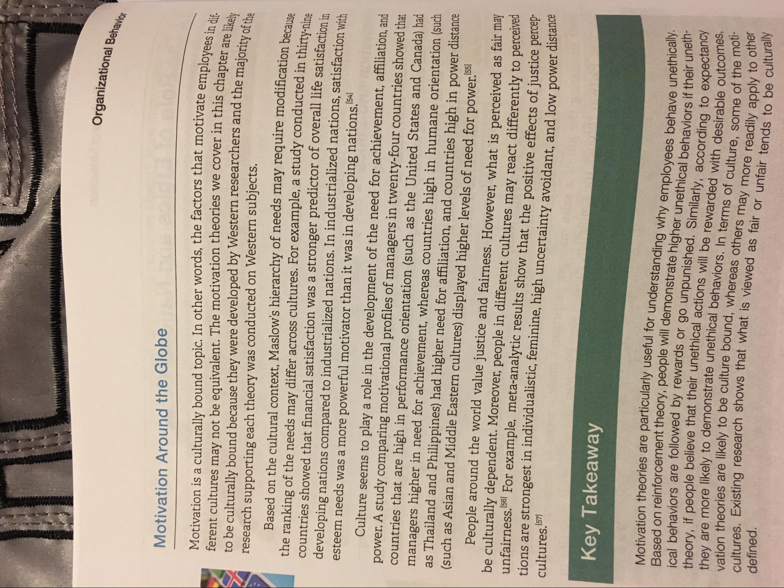
Organizational Behav
Motivation Around the Globe
notivate employees in dif
n this chapter are likely s and the majority of the
Motivation is a culturally bound topic. In other words, the factors that motivate emplove ferent cultures may not be equivalent. The motivation theories we cover in this chant to be culturally bound because they were developed by Western researchers and the maior research supporting each theory was conducted on Western subjects.
Based on the cultural context, Maslow's hierarchy of needs may require modification ha the ranking of the needs may differ across cultures. For example, a study conducted in thirtycountries showed that financial satisfaction was a stronger predictor of overall life satisfaction in developing nations compared to industrialized nations. In industrialized nations, satisfaction with esteem needs was a more powerful motivator than it was in developing nations.154]
Culture seems to play a role in the development of the need for achievement, affiliation, and power. A study comparing motivational profiles of managers in twenty-four countries showed that countries that are high in performance orientation (such as the United States and Canada) had managers higher in need for achievement, whereas countries high in humane orientation (such as Thailand and Philippines) had higher need for affiliation, and countries high in power distance (such as Asian and Middle Eastern cultures) displayed higher levels of need for power.55
People around the world value justice and fairness. However, what is perceived as fair may be culturally dependent. Moreover, people in different cultures may react differently to perceiveu unfairness. (56) For example, meta-analytic results show that the positive effects of justice perceprione are strongest in individualistic, feminine, high uncertainty avoidant, and low power distance
cultures. [57]
Key Takeaway
Motivation theories are particularly useful for understanding why emplovees behave unethically. theory, if people believe that their unethics ical behaviors are followed by rewards or go unpunished einforcement theory, people will demonstrate higher unethical behaviors if their une
d. Similarly, according to expectancy they are more likely to demonstrate unethical behaviors vation theories are likely to be culture bound
warded with desirable outcomes, cultures. Existing research shows that what is view
re likely to demonstrate unethical behaviors. In terms of culture some of the mou defined.
re likely to be culture bound, whereas others may more readily apply to ou a research shows that what is viewed as fair or unfair tends to be culturally
adily apply to other

